FOR IMMEDIATE RELEASE
Contact: Robin Starkenburg, Digi-Star;
robin.starkenburg@digi‐star.com; 920‐568‐6231

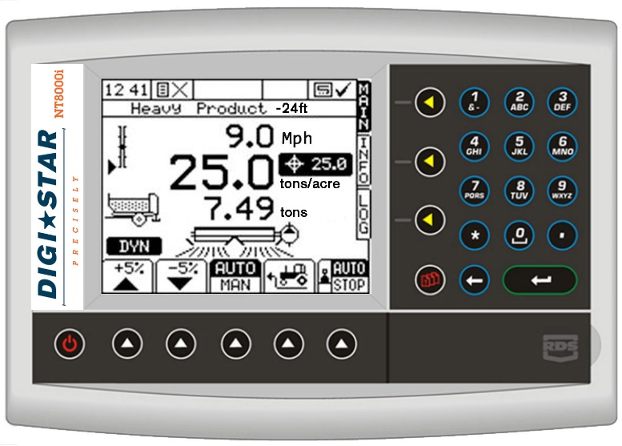

Digi-Star’s NT8000i earns an AE50 award

Fort Atkinson, Wis. [Jan. 15, 2015] – The American Society of Agricultural and Biological Engineers (ASABE) will present Digi-Star with an AE50 award for the NT8000i during their annual meeting in Louisville, Ky. in February.
The NT8000i is a complete rate control system for spreader systems and has been deemed one of the year's most innovative designs in engineering products or systems for the food and agriculture industries.
Chris Horton, Digi-Star product development manager, said, "The NT8000i provides the precision control and automated traceability that the spreading industry demands.”
Digi-Star’s general manager Kevin Klubertanz said, "It has been a tremendous joint effort between our North American and United Kingdom development teams to introduce the NT8000i, and we are very excited about its far reaching potential."
Companies from around the world submit entries to the annual AE50 competition, and up to 50 of the best products are chosen by a panel of international engineering experts. The judges select products that will best advance engineering for the food and agriculture industries.
The NT8000i will be featured in the Digi-Star booth (South Wing B, #933-935) during the National Farm Machinery Show. It is also featured in the January/February 2015 special AE50 issue of ASABE's magazine Resource: Engineering & Technology for a Sustainable World.
For more information on the NT8000i, call (920) 563-1400 or email: sales@digi-star.com.

Digi-Star LLC (http://digi-star.com/) is headquartered in Fort Atkinson, Wis., with additional facilities and businesses in the Netherlands and United Kingdom. Digi-Star LLC is a global supplier of electronic sensing equipment, precision sensors, displays and software used by farmers and other equipment operators to precisely measure and analyze valuable data from critical farming processes.

###

