FOR IMMEDIATE RELEASE
Contact: Robin Starkenburg, Digi-Star;
robin.starkenburg@digi‐star.com; 920‐568‐6231

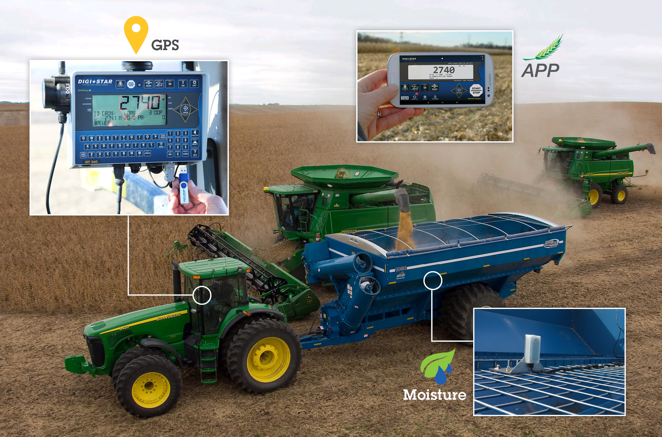
Introducing the Harvest Tracker System™ from Digi-Star

Fort Atkinson, Wis. [Feb. 10, 2016] – Digi-Star introduces the GT 560 Scale Indicator as part of the new Harvest Tracker System™ during the National Farm Machinery show in Louisville, Ky., through Feb. 13. In addition to tracking harvest scale data via a phone or tablet, farmers will also be able to automatically record location and grain moisture content with the new indicator.
Product planning manager, Chris Horton said, “There are numerous new features in this system such as increased microprocessor power, an hour meter, a maintenance message reminder, field location recording of loading and unloading points, and grain moisture recording with dry bushel calculation.”
The easy to use GT 560 Scale Indicator is designed to work with grain carts, gravity boxes, and forage boxes. Horton said, “It can even be fitted to bale transport wagons or trailers.”
The GT 560 scale indicator replaces the highly successful GT 460 and retains all of the functions and features of the GT 460 including automatic recording of unloaded weight data, operator warnings to aid in preventing overloaded trucks, and Harvest Tracker™ PC and on-line software to manage the harvest data recorded by the GT 560.
Location and moisture recording are options for the GT 560. Location is provided by a standard GPS Device making it easy to switch tractors. Grain moisture is provided by a proven, reliable, accurate, temperature-compensated sensor that measures grain moisture as the grain cart is emptied.
Harvest Tracker™ software not only manages the data but also provides simple mapping information to show where loading and unloading took place. Farmers interested in learning more should contact their grain cart dealer to order a system for the 2016 Harvest.
Digi-Star LLC (digi-star.com), a Topcon Positioning Group company, is headquartered in Fort Atkinson, Wis., with additional facilities and businesses in the Netherlands and United Kingdom. Digi-Star LLC is a global supplier of electronic sensing equipment, precision sensors, displays and software used by farmers and other equipment operators to precisely measure and analyze valuable data from critical farming processes.

###

