Calling all youth exhibiting livestock projects - Be a Digi-Star Champion
Enter to win a livestock scale from May 1 – May 30.

Fort Atkinson, Wis. [April 30, 2015] – The 2015, Be a Digi-Star Champion Contest runs May 1- May 30. Youth livestock exhibitors are eligible to enter by posting a picture of their 2015 livestock project to Digi-Star's Facebook page, www.facebook.com/DigiStarLLC. The photo that receives the most votes will win their choice of an Alleyway or Wrangler Jr. Livestock scale, or a StockWeigh 300 indicator.

The 2014, winning photo of Drake and Alyssa Hoyt and their market lambs received more than 1,200 likes. They chose a Wrangler Jr. Livestock scale with a StockWeigh 300 indicator as their prize.
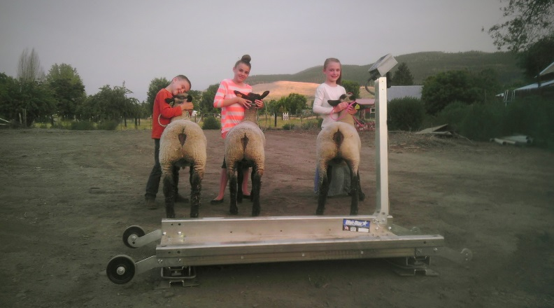
"It is awesome! So far we've weighed six pigs, three sheep, three dogs and all the kids. It transports easily in the back of my pick up and it's nice it only needs 2AA batteries to operate," says Justin Hoyt, Drake and Alyssa's dad.

“Digi-Star has deep roots in agriculture and the Be a Digi-Star Champion Contest is just one of the ways we can share our passion with the next generation,” says Nicole Turner, Digi-Star animal products manager.

Recognizing that access to a scale often limits this key measurement process, Digi-Star developed the Be a Digi-Star Champion Contest in 2013. The winner will be the exhibitor whose picture receives the most Facebook votes by 5:00p.m, May 30, 2015. After the contest ends, anyone that entered will receive a special discount code for Digi-Star's online store. The contest is open to all youth under 21 exhibiting livestock during the 2015 show season.

In an ongoing effort to support youth livestock education, Digi-Star also offers specific discounts to Vo-Ag instructors for livestock scale systems purchased online at Digi-Star.com. Instructors simply need to call 800-225-7695 and request the Vo-Ag coupon code. For more information call (920) 563-1400 or email: sales@digi-star.com.

Digi-Star LLC (http://digi-star.com/), a Topcon Positioning Group company, is headquartered in Fort Atkinson, Wis., with additional facilities and businesses in the Netherlands and United Kingdom. Digi-Star LLC is a global supplier of electronic sensing equipment, precision sensors, displays and software used by farmers and other equipment operators to precisely measure and analyze valuable data from critical farming processes.
###

