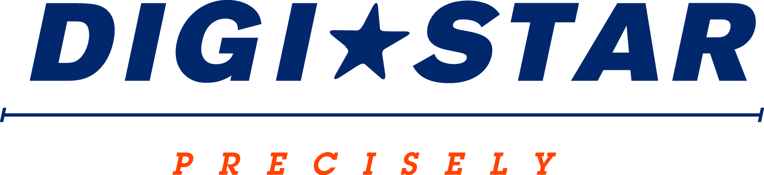
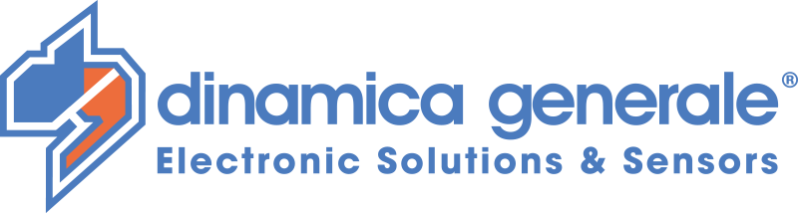

FOR IMMEDIATE RELEASE
Contact: Robin Starkenburg, Digi-Star;
robin.starkenburg@digi‐star.com; 920‐568‐6231

Digi-Star and Dinamica Generale S.p.A. form an NIR partnership expanding product access in North America

Fort Atkinson, Wis. [September 3, 2014] – Digi-Star LLC has formed a Near-infrared (NIR) partnership with Dinamica Generale S.p.A. to offer multiple NIR product solutions to North American producers. In addition to a portable NIR Moisture testing device, Digi-Star is now distributing two NIR feedstuff analyzing tools. Allowing farmers to gain near instantaneous dry matter, starch, crude protein and other valuable nutrient readings with the ability to adjust their ration on the go at the mixer.

This expanded line will include Dinamica Generale’s patented solutions dg precisionFEEDING™ (a bucket loader NIR system), AgriNIR™ (a portable suitcase NIR lab)” and the Digi-Star Moisture Tracker™ (patent pending).

"Digi-Star and Dinamica Generale decided to join efforts to provide maximum value to North American farmers through a common distribution of an innovative line of products based on NIR technology providing the market with a high technology answer for the forage feeding markets of dairy and beef," said Andrea Ghiraldi, CEO and owner of Dinamica Generale S.p.A.

"These products allow producers to get real time analysis about the dry matter and the nutritional values of their forages directly in the field and at bunk side, changing feed management to improve control, farm efficiency and profits," said Kevin Klubertanz, general manager of Digi-Star.

dg precisionFEEDING™ is a kit that allows feeding an animal the optimal ration as programmed by the nutritionist. The NIR analyzer installed directly in the bucket of the loader is able to measure the dry matter (DM) and nutrients of forages and recalculate in real time the target weight for the loading ingredient in order to keep the total mixed ration (TMR) consistent.

AgriNIR™ is a portable NIR analyzer for forages and grains that quantifies, in seconds, the percentage of Humidity or Moisture (dry matter), Starch, Crude Protein, ADF, NDF, Ash and Crude Fat of the plant material being analyzed.

The Moisture Tracker™ is a hand-held NIR scanning device that rapidly measures the DM and moisture content of animal feeds. The Moisture Tracker™ device provides livestock producers with near instantaneous, accurate DM and moisture readings which enable livestock producers to quickly react to changes in DM thus ensuring that the ration delivered matches the ration calculated.

Digi-Star is a global precision agriculture company based in Fort Atkinson, Wis. It provides innovative control, sensor and weighing systems along with software solutions for the agriculture industry.

Dinamica Generale S.p.A. is a global company located in Italy, with additional locations in U.S. and Ukraine. Dinamica Generale S.p.A. designs and manufactures advanced sensor technology solutions for agri-business and livestock management;

For more information call (920) 563-1400 or email: sales@digi-star.com; for technical details please email: Nir.support@dinamicagenerale.com

Digi-Star LLC (http://digi-star.com/) is headquartered in Fort Atkinson, Wis., with additional facilities and businesses in the Netherlands and United Kingdom. Digi-Star LLC is a global supplier of electronic equipment, precision sensors, displays and software used by farmers and other equipment operators to precisely measure and analyze valuable data from critical farming processes.
###

