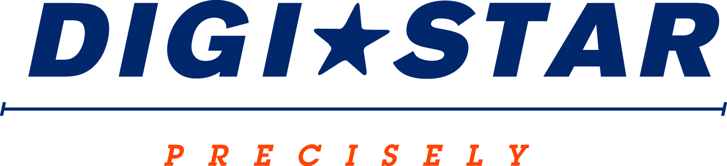

FOR IMMEDIATE RELEASE
Contact: Robin Starkenburg, Digi-Star;
robin.starkenburg@digi‐star.com; 920‐568‐6231

Where did my feed go? Reduce shrink and improve ration consistency through feed management software
Digi-Star & Scale-Tec to offer daily educational sessions at New York Farm Show, Feb. 26-28.
Fort Atkinson, Wis. [February 17, 2015] – Digi-Star’s Tera Koebel Baker will be presenting educational sessions on improving profitability through feed management at the New York Farm Show, held Feb. 26-28 at the New York State Fairgrounds, Syracuse, N.Y.
These sessions are open to the public and will be in Home and Arts Center from 11:30-12:30 each day. Baker will highlight common shrink and dry matter consistency issues and how a feed management system can help producers of all sizes recoup lost dollars through employee training, regular dry matter testing and feed management software.
“Setting up and using a feed management program on a day-to-day basis is much easier than most would assume,” says Baker. “Once a program is in place, daily feeding adjustments and communication between management and feeding staff are more seamless, and the data collected can be applied immediately to reduce feed losses and improve efficiencies to create a quick return on investment.”
Baker will walk through Digi-Star’s TMR Tracker software allowing attendees an up close and personal look at the software, customization options and the reports generated for analysis. She will also showcase some of Digi-Star’s new technologies that can enhance on-farm precision feeding programs, and demonstrate how these tie together with feeding programs.
Visit Digi-Star’s booth during the New York Farm Show (booth #D629) to learn more about Digi-Star’s precision feeding technology. For more information, call (920) 563-1400 or email: sales@digi-star.com.
Digi-Star LLC (http://digi-star.com/) is headquartered in Fort Atkinson, Wis., with additional facilities and businesses in the Netherlands and United Kingdom. Digi-Star LLC is a global supplier of electronic sensing equipment, precision sensors, displays and software used by farmers and other equipment operators to precisely measure and analyze valuable data from critical farming processes.

###

