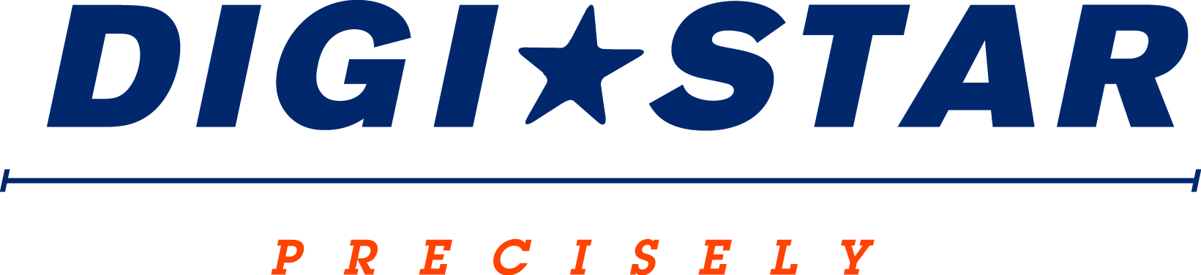

FOR IMMEDIATE RELEASE
Contact: Robin Starkenburg, Digi-Star;
robin.starkenburg@digi‐star.com; 920‐568‐6231

Digi-Star to host educational sessions at World Dairy Expo
Daily educational sessions to cover all things wireless in precision feeding.

Fort Atkinson, Wis. [Sept. 15, 2014] – Digi-Star will be hosting a series of educational sessions for dairy producers at World Dairy Expo. The educational sessions will help dairy producers untangle the new precision feeding technology available today. Sessions will take place daily in the Digi-Star hospitality tent #731, located in the outdoor trade mall.
“Technology offers immense opportunities for dairymen to improve feed management, but with those opportunities also come significant challenges. These challenges can be easily overcome with some basic analysis," says Chris Horton, Digi-Star product development manager.
Class schedule:
- Radios, Apps and WiFi Oh My! will be held at 4:00 p.m. on Tues. (9/30), Wed. (10/1) and Fri. (10/3).
This session will discuss available precision technology including mixer wagon technologies, radio, WiFi and app technology. Attendees will learn how different technologies fit varying styles of farming and will be provided a list of questions that will help them work with local equipment dealers to identify the best technology and system to meet their individual farm needs. Anyone with multiple mixers, feeders and farms will benefit from attending.

- TMR Tracker Training will be held at 10:00 a.m. and 2:00 p.m. on Tues. (9/30), Wed. (10/1), Thurs. (10/2), Fri. (10/3) and Sat. (10/4). This session will identify how the TMR tracker program can improve farm management, how to implement the system on the farm, a look at features that might be underutilized on-farm, and how to implement and benefit from the new features being released this fall. Anyone that is a current TMR Tracker user or is a potential user will benefit from attending.

- NIR Precision Feeding will be held at 1:00 p.m. on Tues. (9/30), Wed. (10/1), Thurs. (10/2) and Fri.(10/3). This session will help explain what NIR technology is and how it compares with other feed analysis options. Supporting nutrition consultants Dr. John Goeser and Courtney Heuer from Rock River Laboratory will be presenting. These sessions will provide an explanation of NIR technology, demonstrate NIR technology precision and accuracy relative to other moisture measures, and review proper sampling techniques and protocols to gather an accurate feedstuff moisture analysis.

Educational sessions are free to World Dairy Expo attendees and will be held in the Digi-Star hospitality tent #731, located in the outdoor trade mall. For more information call (920) 563-1400 or email: sales@digi-star.com.
Digi-Star LLC (http://digi-star.com/) is headquartered in Fort Atkinson, Wis., with additional facilities and businesses in the Netherlands and United Kingdom. Digi-Star LLC is a global supplier of electronic sensing equipment, precision sensors, displays and software used by farmers and other equipment operators to precisely measure and analyze valuable data from critical farming processes.

###

