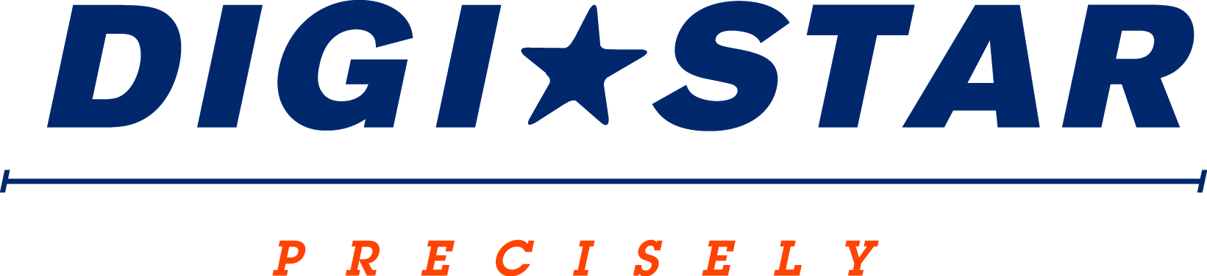

FOR IMMEDIATE RELEASE
Contact: Robin Starkenburg, Digi-Star;
robin.starkenburg@digi‐star.com; 920‐568‐6231

: 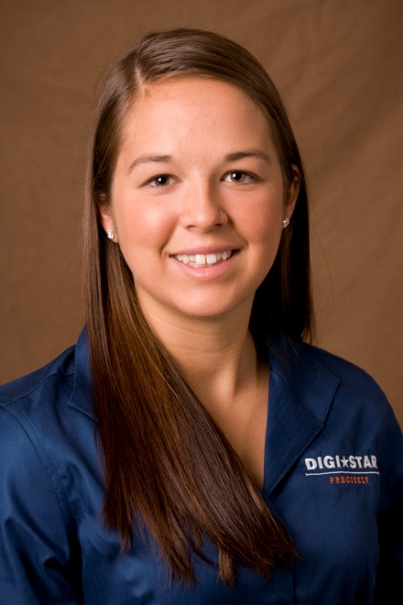

Turner named StockWeigh sales representative

Fort Atkinson, Wis. [August 15, 2014] – Nicole Turner has been appointed StockWeigh technical sales representative for Digi-Star, LLC a Wisconsin based manufacturer of advanced measuring systems and software used in the precision agriculture sector.
"Nicole has fantastic customer service skills and on-farm experience making her a great addition to the Digi-Star sales team," said Digi-Star sales manager, Jack Danner. Danner added, "Her passion for youth programs and understanding of on farm systems will be a great fit to support our StockWeigh customers.
Turner previously worked with Langkamp Dairy Crosses and the Williams Homestead Farm and Creamery. She has additional experience working with herd management software. She holds a B.S. in Animal Science from the University of Wisconsin - Platteville.
Turner is based out of the Digi-Star Fort Atkinson office and will provide sales support to Digi-Star's full line of StockWeigh solutions including the recently released Caf Cart® with Scales.
For more information call (920) 563-1400 or email: sales@digi-star.com.

Digi-Star LLC (http://digi-star.com/) is headquartered in Fort Atkinson, Wis., with additional facilities and businesses in the Netherlands and United Kingdom. Digi-Star LLC is a global supplier of electronic sensing equipment, precision sensors, displays and software used by farmers and other equipment operators to precisely measure and analyze valuable data from critical farming processes.
###

