FOR IMMEDIATE RELEASE
Contact: Robin Starkenburg, Digi-Star
robin.starkenburg@digi‐star.com; 920‐568‐6231

Images available for download: http://bit.ly/1AK8oWe

NT 8000i rate control for manure spreaders now available

Fort Atkinson, Wis. [June. 29, 2015] –Digi-Star introduces the NT 8000i rate control system for manure spreaders. The NT 8000i is a weight-based system that improves application efficiency by varying the unloading rate in proportion to ground speed.

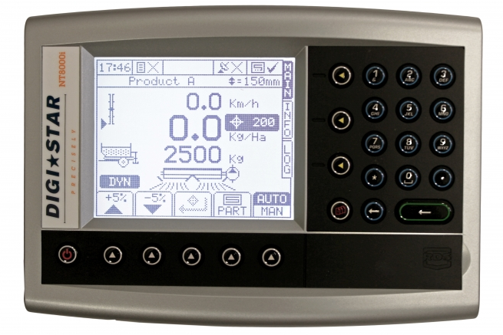
The NT 8000i is a closed-loop rate control system designed to provide precision guidance and prescription-based control of the spreading rate in hydraulically driven apron floor systems on manure spreaders using data collected and evaluated in real time.

“The unique feature of the NT 8000i is the weight-based self-calibration and calibration-check system that continuously monitors and readjusts the calibration factor based on the actual weight of the material spread,” says Jack Danner, Digi-Star sales manager. “The NT 8000i system provides enhanced spreading rate accuracy when working with challenging materials of varying densities such as manure, litter or compost.”

With complete as-applied data records saved to an SD card, NT 8000i applicators are equipped with automated traceability allowing them to meet the recordkeeping needs of land owners and government agencies. The system also reduces operator mistakes and fatigue with its fully automated spreader controls.

The NT8000i earned an AE50 award from the American Society of Agricultural and Biological Engineers (ASABE) earlier this year. AE50 awards recognize the most innovative designs in engineering products or systems for the food and agriculture industries.
For more information on the NT8000i, call (920) 563-1400 or email: sales@digi-star.com.

Digi-Star LLC (http://digi-star.com/), a Topcon Positioning Group company, is headquartered in Fort Atkinson, Wis., with additional facilities and businesses in the Netherlands and United Kingdom. Digi-Star LLC is a global supplier of electronic sensing equipment, precision sensors, displays and software used by farmers and other equipment operators to precisely measure and analyze valuable data from critical farming processes.
###

Images available for download: http://bit.ly/1AK8oWe

DGS_NT 8000i Release_063015.jpg – This map shows the target rate of nutrient application in a field. The NT 8000i weighs materials as they are being spread, calculates ground speed and adjusts the rates accordingly in order to meet the target rate.

